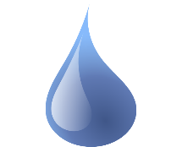
UTAH IS IN A
DROUGHT LETS DO OUR PART & REDUCE WATER USE BY 20%.
WHAT DOES A 20% REDUCTION in water use look like?

AVERAGE DAILY USE- The average resident uses 220
Gallons of water per day. Here are some easy ways to
reduce water use. Find the combination for you
to reduce by 20% or 44 gallons a day.

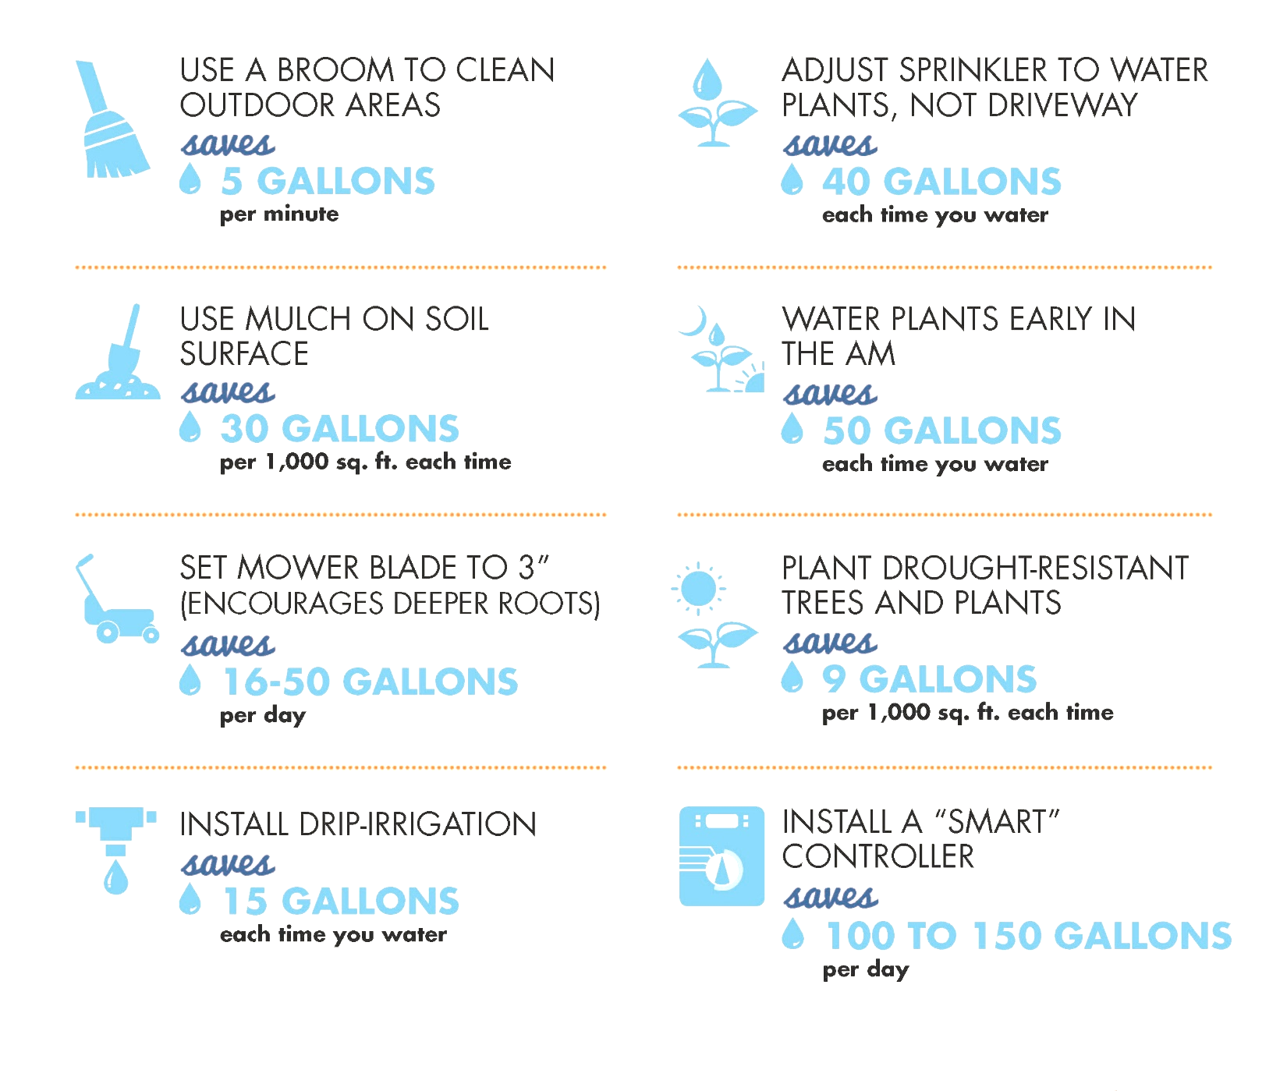
Here are some more tips in addition to the State of Utah Department of Water Resources.

